

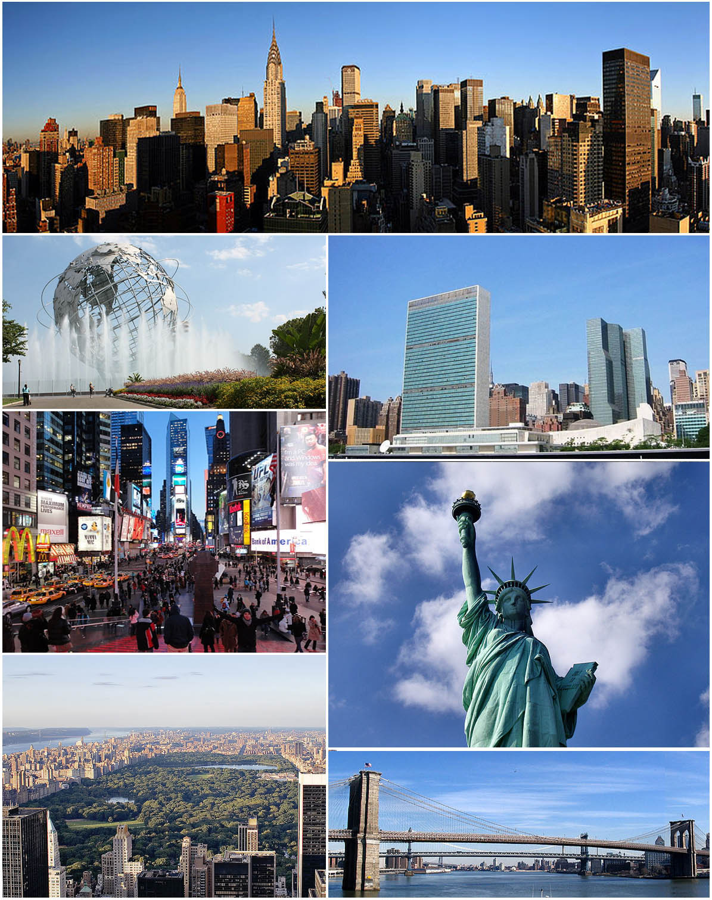
Dear Mr Dudka,
I’m writing this email from USA. The weather is really hot at the moment but I really like it here because the people are friendly. We’re driving around the New York and we’re stopping in different places.
We’re just arrived here in Manhattan. In lost few days we’ re driven trough beautiful Times Square and fantastic Statue of Liberty. So far I’ve really enjoyed the food and we haven’t had any but experiences.
Tonight we’re staying in Central Park in city of New York. Tomorrow we’re going to travel by taxi on Brooklyn Bridge. It should be fun.
Yours sincerely, Simon.

