Week 2 – answers
Student's Book p. 72 ex. 1, 3, 4
Ex. 1
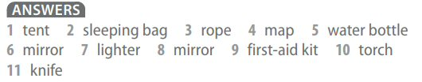
Ex. 3
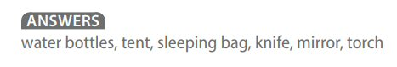
Ex. 4
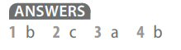
Student's Book p. 108 ex. 1, 2, 3, 4
Ex. 1
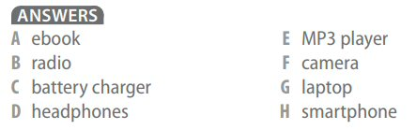
Ex. 2
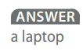
Ex. 3
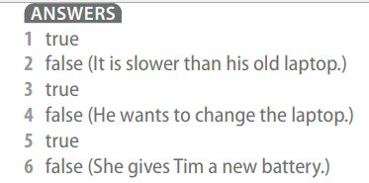
Ex. 4
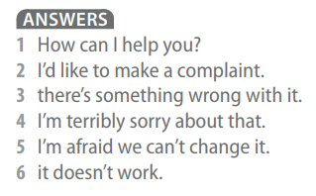
Workbook p. 26 ex. 1, 2
