Week 1 – answers
Student's Book p. 76. ex. 1-6
Ex. 1
Ex. 2
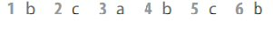
Ex. 3
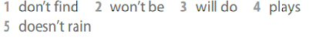
Ex. 4
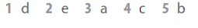
Ex. 5
Ex. 6
