Week 2 – answers
Student's Book p. 105 ex. 1, 2, 3
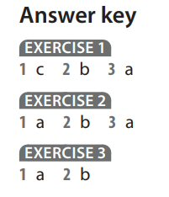
Student's Book p. 106 ex. 1, 2, 3, 4
Ex.1
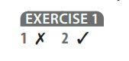
Ex. 2
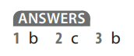
Ex. 3
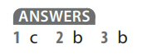
Ex. 4
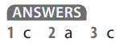

Student's Book p. 107 ex. 1, 2, 3
