Week 1 – answers
Student's Book p. 70 ex. 1,4
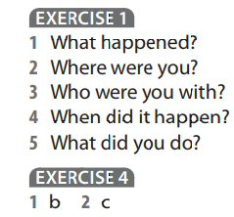
Student's Book p. 71 ex. 1,2
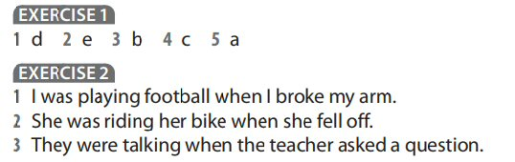
Student's Book p. 72 ex. 2
