Week 2 – answers
Student's Book p. 109 ex. 1, 2
Ex. 1, 2
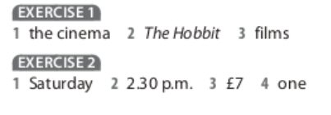
Student's Book p. 101 ex. 1, 2
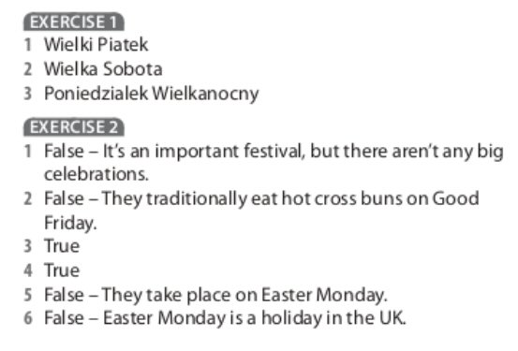
Workbook p. 33 ex. 1, 2, 3, 4
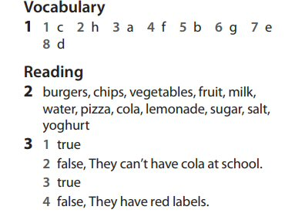
Ex. 4
- tomatoes, yoghurt, honey
- Bananas
- 6 o’clock
- healthy

