Week 3 – answers
Student's Book p. 70 ex. 1
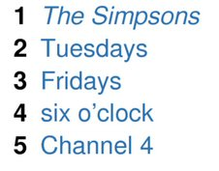
Student's Book p. 70 ex. 4
A.What’s your favourite TV programme?
B.My favourite TV programme is The Crazy Teachers.
A.What day is it on?
B.It’s on Mondays and Thursdays.
A.What time is it on?
B.It’s on at half past six.
A.What channel is it on?
B.It’s on Polsat.

Student's Book p. 71 ex. 1

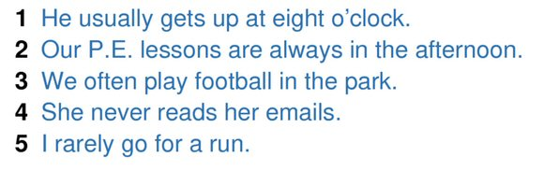

Student's Book p. 71 ex. 2

