Week 2 – answers
Student's Book p. 105 ex. 1, 2, 3
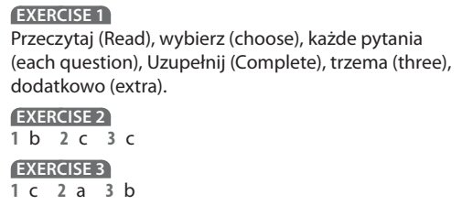
Student's Book p. 106 ex. 1, 2, 3, 4
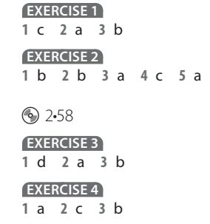
Student's Book p. 108 ex. 1, 2, 3, 4
