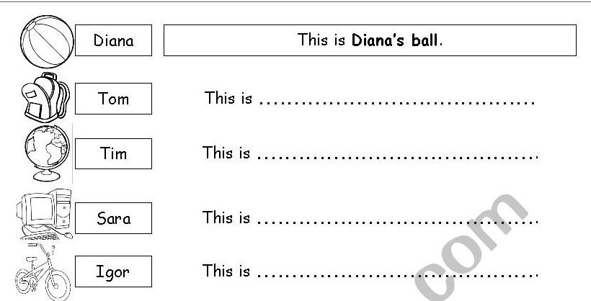b
my sisters
girls’ ball.
girls
students
children
brothers
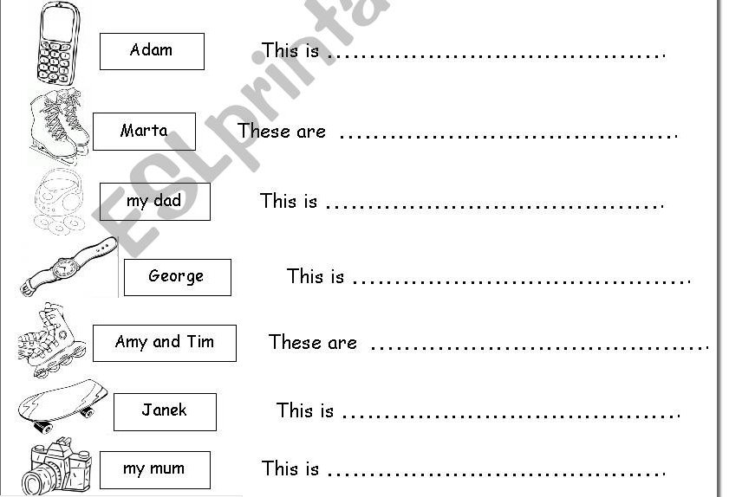
my parents
my friends
my grandparents
my cousins
rollerblades – rolki
skateboard – deska do skateboardingu
cd player – odtwarz płyt
ice skates – łyżwy
globe – globus
watch - zegarek

