- Znajdź i zakreśl jeszcze siedem nazw przedmiotów.
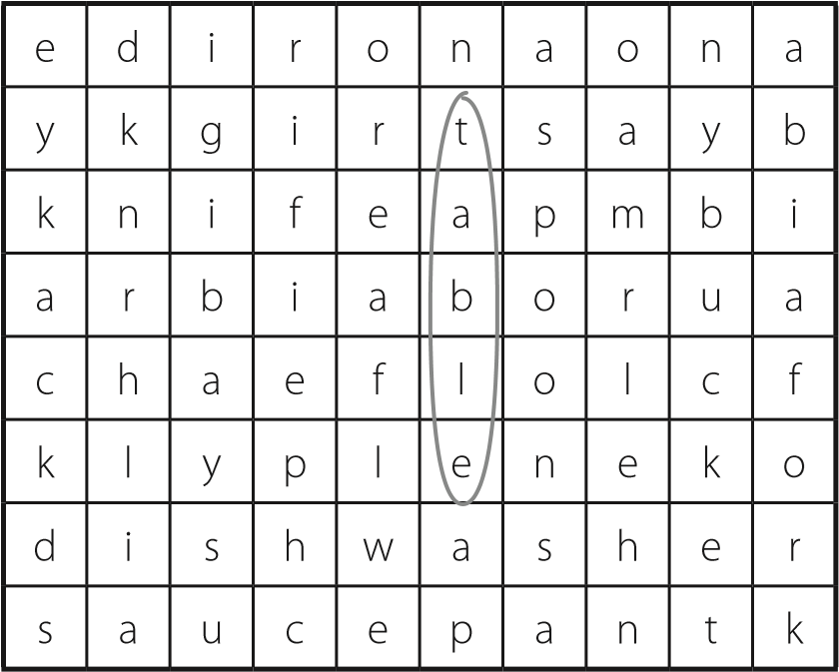
- Uzupełnij zdania czasownikami z ramki w formie przeczącej czasu present continuous.
watch walk wear listen learn help
I ’m not learning | Japanese. It’s Chinese!
1 My friend got a new dress. | jeans. She’s
2 We | TV. We’re reading.
3 Dad | Mum in the
kitchen. He’s in the garden.
- They to school this morning. It’s cold.
- You to me!
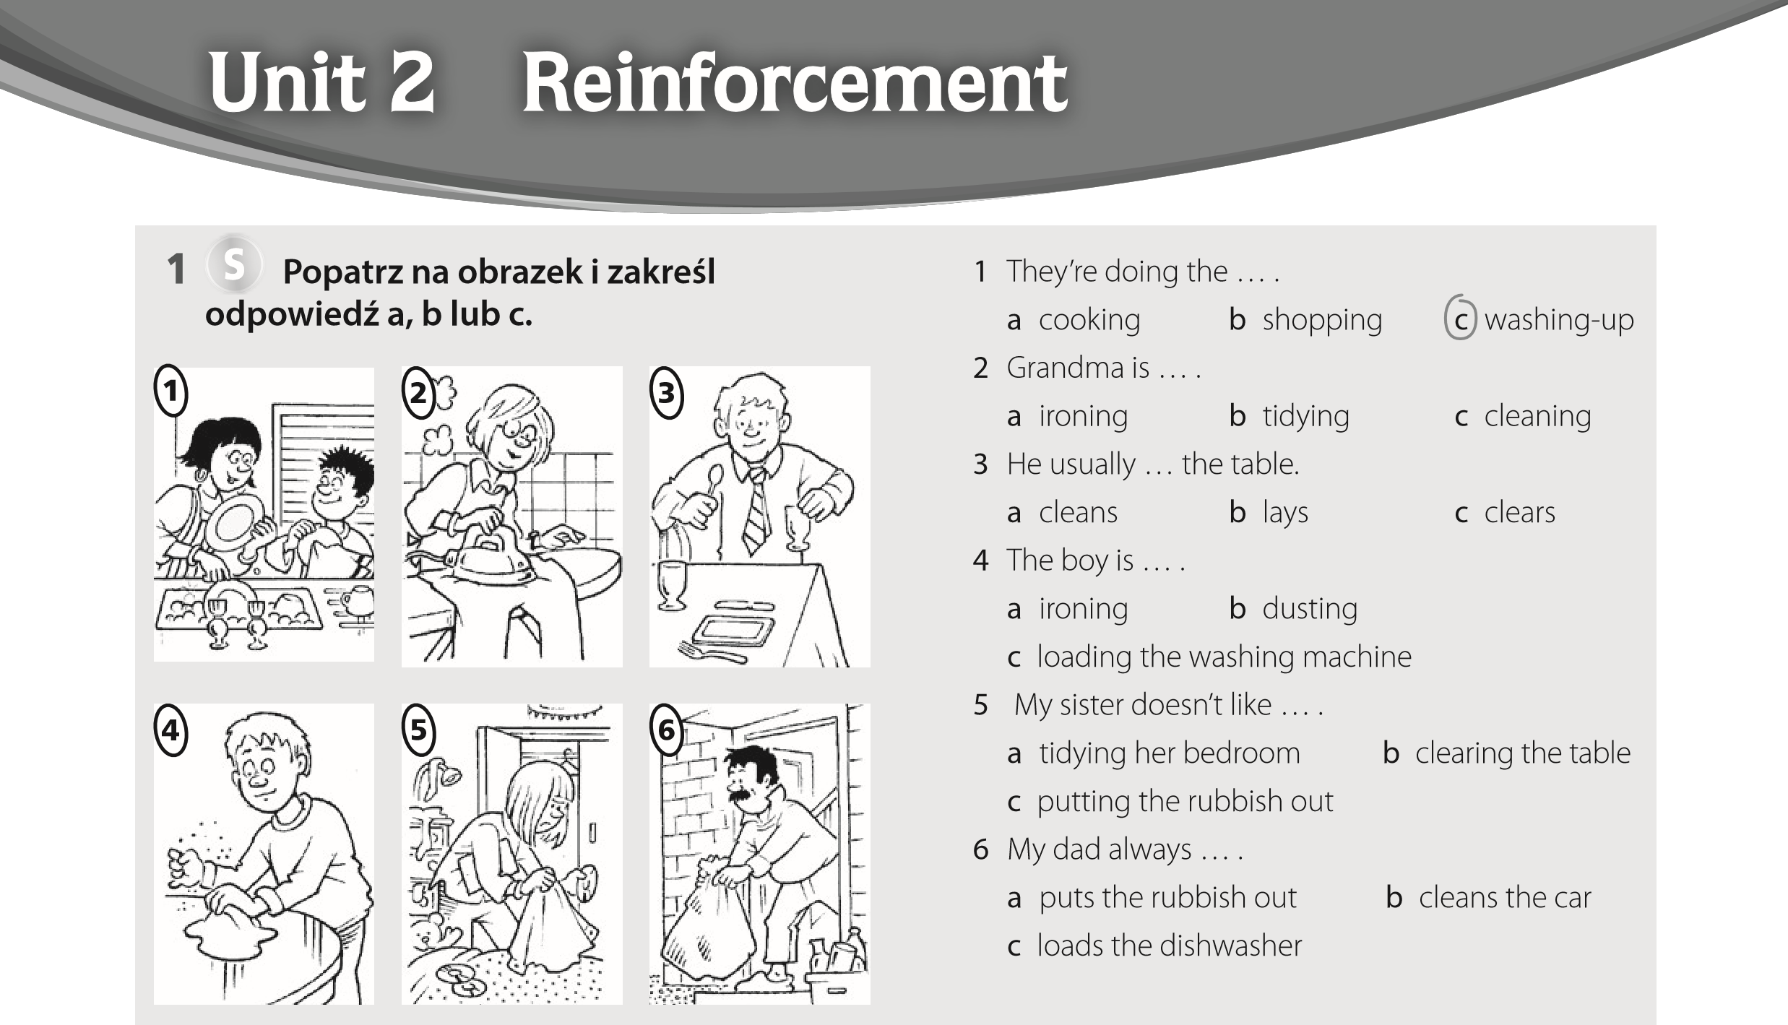
- Uzupełnij zdania właściwymi przysłówkami.
The children are playing happily . (happy) 1 Talk ! The baby is sleeping! (quiet)
  - You play the piano so ! (good)
  - Our dog eats . (noisy)
  - Walk , please! We’re late! (quick)
  - You’re driving . Slow down! (fast)
- Ułóż i napisz zdania. Użyj czasu present simple lub present continuous. What / do / at the moment?
What are you doing at the moment?
  - He / watch TV / every afternoon.

  - She / play tennis / now.

  - they / come / today?

  - We / eat hamburgers / once a week.

S
- Zakreśl właściwą odpowiedź.
  - I’m sorry, but I left your book at home. a Never mind. b Thank you. c Where is it?
  - Have you got my DVD?
PHOTOCOPIABLE ^{© Oxford University Press} Unit 2 Reinforcement worksheet Team Up Plus dla klasy V
a Sorry I’m late. b Yes, here you are. c It doesn’t matter.
jest w domu? Zakreśl właściwą odpowiedź: a, b lub c.
a Three b Four c Five Lily Hi Sarah! Are you doing your homework?
Sarah Hi Lily! No, I’m not doing my homework, I’m hanging up my clothes. Every Saturday I help
my mum with the housework.
Lily Oh, me too! I’m doing the washing-up now.
Sarah Is your brother helping you?
Lily No, he’s in the garden.
Sarah Is he playing football?
Lily No, he isn’t playing a game. He’s cleaning the windows! My mum is in the kitchen, my dad is at work, and my baby sister is sleeping.
Sarah She’s so cute! Is your mum making lunch?
Lily Yes, she is. We’re having bacon and eggs. Why don’t you come to my house for lunch?
Sarah I’m sorry, but my grandad is visiting us today. Lily It doesn’t matter. See you at school. Bye!
S
2 Przeczytaj dialog z ćw. 1 jeszcze raz. Wybierz poprawną odpowiedź. Zakreśl a, b lub c.
- What is Sarah doing? a 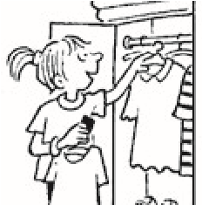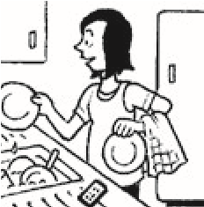
b

c
- What is Lily doing? a 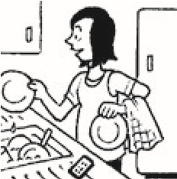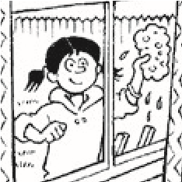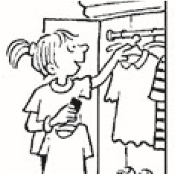
b

c
- What is Lily’s brother doing? a 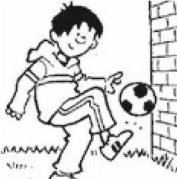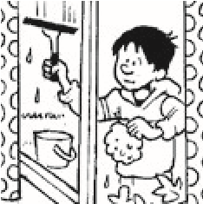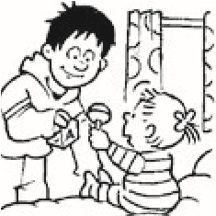
Un
i
t 2
Ext
e
ns
i
on
1

Przeczytaj dialog. Ilu członków rodziny Lily
3

Przeczytaj dialog z ćw. 1 jeszcze raz. Popraw
b

c
- Who is visiting Sarah today?
a 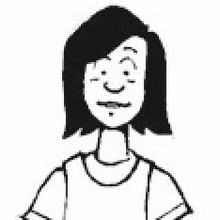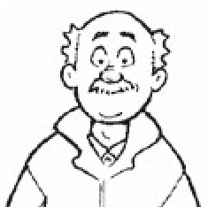
b

c
poniższe zdania wypowiedziane przez Lily. I’m doing my homework. I’m not doing my homework. I’m doing the washing-up.
- My brother is reading.

- My mum is cooking dinner.

- We’re having pancakes.

- My sister is playing.

- Napisz przysłówki utworzone od podanych przymiotników. Potem uzupełnij zdania właściwymi przysłówkami.
Przymiotnik | Przysłówek
bad | badly
good
early
happy
He isn’t a good driver. He drives b a d l y. 1 She’s a fantastic dancer. She dances really
.
  - The children are friends. They’re playing together.
  - We get up every morning and we go swimming before school.
- Uzupełnij dialog wyrażeniami z ramki. Jedno wyrażenie zostało podane dodatkowo i nie pasuje w żadnym miejscu dialogu.
a Where is it? b Don’t eat it too quickly
c Sorry I’m a bit late d Never mind e That’s not fair
Mum | Lily! Lunch is ready.
Lily | Coming, Mum! Where’s Sam?
Mum | He’s finishing the windows.
Lily | He’s always late!
Mum | e , Lily. Sam is working really hard.
Sam  Mum | Here I am. ¹ , Mum.  ² . Your food is on the table.
Sam | Thanks. Bacon and eggs is my favourite meal!
Mum | ³ , Sam!

PHOTOCOPIABLE © Oxford University Press Unit 2 Extension worksheet Team Up Plus dla klasy V

