- Mental health specialists can be in short supply (and there’s a lot of need right now), so be open to the possibility of care being delivered remotely, through telehealth.
- he easiest way to ask a child about suicidal ideation is "Have you ever wished that you could go to sleep tonight and not ever wake up?" This bypasses knowledge of death, and focuses on the wish to escape pain. I wished someone had asked me this question when I was in 4th Grade.
- In NYC the treatment available to young children right now is tele-therapy for like $300/session, not covered by insurance. It's a complete joke and waste of money. I don't know how you can claim that tele-therapy is adequate care for young children. I am so disgusted by what we did to children in the name of "taking covid seriously."
- San Marino has been a political anomaly, its identity built on standing apart, ever since its founding, according to tradition, in 301 by its namesake, St. Marinus, a stonecutter who settled amid the craggy caves of Monte Titano in the Apennines.
- @Sutter Russia's vaccine is an Adenovirus-vector vaccine that leverages two different Adenoviral strains to get the encoded spike protein into the cells--AD26 and AD5. Using two different strains for each dose helps counter vector immunity and improves the efficacy of the vaccine (something J&J and AstraZeneca are struggling with). Russia's RDIF has already expressed its willingness to share its vaccine specifications with any willing partner--they simply need manufacturers to produce it.
- @Anton Kucinski Anton, I struggle to understand why you state the following: "...it appears there's a legit case that Sputnik isn't as effective as the others." I'm no fan of the Kremlin, but let's set all politics aside because medicine always comes first. Let's focus on science, which we must always do. Gamaleya's Sputnik-V vaccine is an excellent product that has demonstrated a very high level of efficacy comparable to BioNTech and Moderna's mRNA vaccines. Their efficacy statistics were peer-reviewed and published in the reputable Lancet Journal. Russian scientists have also been quite transparent about how their vaccine works and why it's so efficacious especially relative to other Adenovirus-vector vaccines. Adenovirus-vector vaccines leverage the Adenovirus as a delivery mechanism. The Adenovirus contains the genetic code for the spike protein and shuttles this code into the cells, where intracellular machinery begins producing this spike protein and expresses it to the immune system, which then starts working on relevant antibodies. But--our immune system not only develops immunity to the encoded spike protein (as it should) but also to the Adenovirus strain. This makes the second dose possibly less efficacious as the body now has immunity to the vector. Russia's scientists predicted this and made the conscious decision to use two different adenoviral strains--AD5 and AD26. Their vaccine is an excellent product, from a scientific standpoint.
- Most of the rest of tech has opted to put on sackcloth and ashes and make a million meaningless apologies to the public and Congress for a wide variety of mishaps over the years. But Mr. Bezos is being deliberately provocative in an attempt to gain leverage by pointing the blame back at legislators. He’s accusing them of all talk and no action.
- The Indian climbers submitted doctored photos appearing to show them atop the world’s tallest peak, Nepal says. Fake claims of Everest climbs have become common.
- “I don’t know how he got certificate without any photos of the summit,” Mr. Phukon said. The company that organized the duo’s trip said it had “no role at all in morphing the photos.”

- 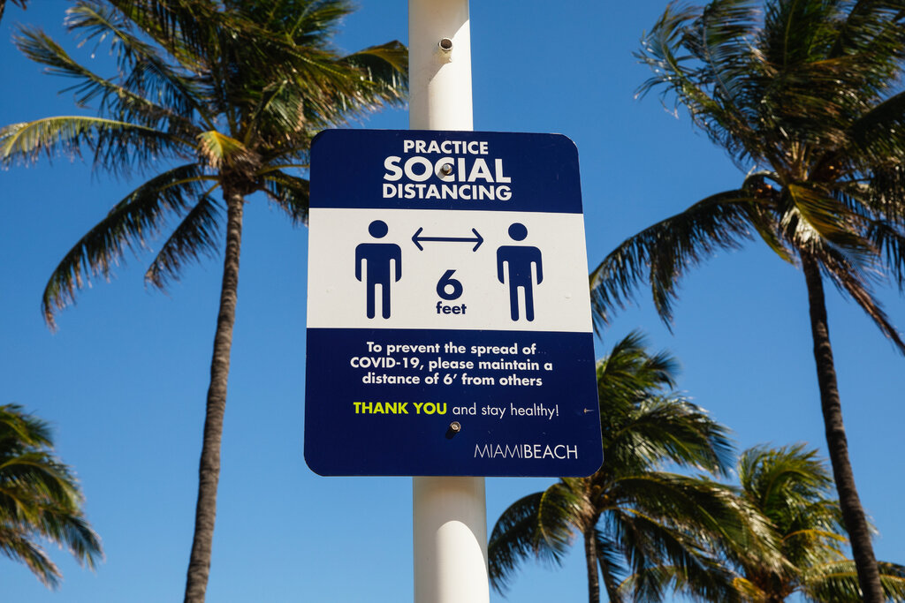

- When Europeans lose their tempers, they punch someone; Americans pull out a handgun. Foreigners express road rage by cursing; a driver in North Carolina recently expressed his by firing shots into another car, killing a mother of six. Abroad, brutish husbands put wives in hospitals; American husbands put wives in coffins.

- Readers also contributed $3.8 million for OneGoal, which helps low-income students in the United States, and $2.3 million for Cure Blindness, which provides sight-restoring cataract surgery in developing countries; that’s enough for more than 46,000 sight-restoring surgeries.

Generał ponad podziałami
Przez całe lata próbowałem pomóc Władysławowi Ślazykowi w załatwieniu mieszkania, bo widziałem, w jakich strasznych warunkach wychowuje w jednym pokoju gromadkę dzieci z biednych rodzin, sierot i półsierot. Pisałem, gdzie tylko było można, bez żadnego skutku. Ślazyk prosił o pomoc krakowskich metropolitów, Wojtyłę i Macharskiego, pisał do kolejnych prezydentów Krakowa, pokazywał mi list do Gierka. Nic nie pomogło.
W połowie 1982 r. Ślazyk przyniósł mi swoje jedyne odznaczenie, a był to przyznany mu przez ministra obrony narodowej srebrny medal „Za zasługi dla obronności kraju” przeznaczony dla rodziców, którzy wychowali wiele dzieci na wzorowych i ofiarnych żołnierzy, a czworo jego wychowanków zostało zawodowymi żołnierzami. Jak widać, nikt wtedy nie myślał, że rodzina to musi być tata z mamą, i on jako człowiek samotny, kawaler, też został uznany za rodzinę i odznaczony. Napisałem więc list do gen. Wojciecha Jaruzelskiego jako zwierzchnika sił zbrojnych. Opisałem, w jakich warunkach żyje pracownik kościoła Mariackiego w Krakowie, który wychował tyle dzieci, w tym czwórkę żołnierzy.
- Zobacz także: Największy pomnik Lenina w Polsce był w Nowej Hucie. Przetrwał 16 lat
Po dwóch tygodniach Władysława Ślazyka odwiedzili dwaj oficerowie z wojewódzkiego sztabu wojskowego i gdy zobaczyli jego mieszkanie, nie chcieli wierzyć, że samotny człowiek w takich warunkach może wychowywać tyle dzieci. Po kilku miesiącach przyszło pismo, że prezydent Krakowa Józef Gajewicz przyznaje Ślazykowi i jego dzieciom, a wtedy mieszkało ich chyba dziesięcioro, czteropokojowe mieszkanie przy ul. Teligi 16 w dzielnicy Prokocim. To piękna historia o tym, że ludzie mogą sobie pomagać ponad podziałami politycznymi i religijnymi – gen. Jaruzelski załatwił mieszkanie pracownikowi kościoła Mariackiego w Krakowie.
Tuż po przeprowadzce Władysław Ślazyk ofiarował mi swoją laskę z nabitymi na nią odznakami, głównie z miast byłego Związku Radzieckiego, bo młodzież zza wschodniej granicy najchętniej dzieliła się z nim takimi odznakami. Przez ponad 30 lat ta laska wisiała w moim mieszkaniu, przypominając mi wspaniałego człowieka. Dziś jest już w bazylice Mariackiej, a ja, myśląc o wszystkich ludziach, których przez lata w życiu spotkałem, przyznaję rację ks. Józefowi z Rzymu, że człowiek od ołtarza mariackiego to również mój kandydat na świętego. Mogę być świadkiem jego dokonań.

The vaccine appeared to be causing an immune reaction in which antibodies bind to platelets, activating them, German doctors and the European Medicines Agency have said. Those platelets, in turn, were causing the formation of dangerous clots in certain parts of the body, including in veins that drain blood from the brain, leading in some cases to a rare type of stroke.
Why the antibodies develop in these people is not known, doctors have said. Some component of the vaccine, or an excessive immune reaction — or both — could be the cause, they said.
No medical condition is known to make patients more vulnerable to this clotting disorder after a vaccination, European regulators said.

Shaun Narine
Fredericton, Canada7h ago
The rapid demonization of China in the Western world is truly frightening and disturbing. China has certainly done some things to encourage this, such as its abuses in Xinjiang. But it is also clear that the focus on these acts in the West is driven by political goals and values. There are many other countries that abuse human rights that the West has no problem with or actually encourages -notably Israel, but there are other states too. The usefulness of human rights as a rhetorical tool is something the US has long understood. We should understand that the US - the country in the world that most frequently abuses and breaks international law -is using Xinjiang as a club to beat China. It is worth noting, too, that the US' human rights record is far from spotless. In the Canadian case, I can say that it is increasingly clear that Canada was manipulated by the US into arresting Meng Wanzhou, the Huawei executive whose arrest led to the incarceration of the "two Michaels." China saw Canada's action as its participation in the US effort to destroy Huawei and undermine China's development. The Chinese are almost certainly right. Today, Canada hides behind an idea of "due process", allowing Meng's extradition hearing to drag on, when the Justice Minister could easily release her and send a message to the US that Canada won't be manipulated. We would also get back the two Michaels. But it seems it has been easier for Canada to kowtow to US threats than China's threats.

TLMischler
Muskegon, MI9h ago
I like your reasoning, Mr. Kristof - we definitely should use the games to highlight the abuses of the Chinese government. However, our governmental leaders should hesitate with the finger pointing until they clean up their own act. I'm talking first about journalists: where is the outrage over Jamal Khashoggi? Where is the accountability? And how much longer does the US government intend to persecute Julian Assange, Edward Snowden, and other whistleblowers whose crimes are identical to those of Daniel Ellsberg? We have been taught to be more outraged at those who released the documents than in the myriad criminal behaviors revealed in those documents. Meanwhile, the Chinese are amazed that we can be so quick to condemn their government's actions while refusing to address the carnage of gun deaths in the US. And then there is our "friendship" with Saudi Arabia, and the extensive list of human rights abuses of that nation. How many children in Yemen have been killed by US bombs? Don't get me wrong - I love this country, and I'm a firm believer that America continues to be the best hope for the world. But no country can effectively condemn another's moral failures while simultaneously turning a blind eye to its own. We can condemn China's treatment of Uygher Muslims while simultaneously addressing our own moral failures; that's what moral people do. But we need to do so with temperance and grace, not with condescension.

Usok
Houston10h ago
Dear Mr. Kristof I totally disagree with your suggestion of boycotting Beijing Winter Olympics in 2022. You accidently politicize a global sport event to vent your dissatisfaction with China. China is hosting an event by inviting all the foreign diplomats in China to visit Xinjiang province where the Uyghur minority were allegedly mistreated. China is very confident that these speculation and rumors will be dissolved quickly. Already the forced labor lies have been overthrown by H&M's own Shanghai office via its research and investigation. And the population of Uyghur has been more than doubled in the last decade. Just read SCMP, the only English newspaper in Hong Kong, and you will find out a lot of things that never have been reported in NY Times or WSJ. Politics is politics. But don't undermine the hard work, tough training and sacrifices that thousands of athletes have to go through every 4 year. There will another day and another place for politics.

To Professor Lang, the prospect of a U.S. poultry invasion is not just an abstract anxiety about agricultural imperialism. It’s a matter of health and safety. He noted that in the late ’80s and early ’90s, Brits were rattled by a number of high-profile food scares and outbreaks involving salmonella, E. coli and mad cow disease. The Food Standards Agency was created in 2000 with a remit to rethink the country’s processing systems. Around the same time, the European Union adopted what it calls the precautionary principle on food and environmental safety.
“If in doubt,” he wrote in an email, summarizing the principle, “the consumer or eco interest triumph over business. Better to assume there might be a problem than pooh-pooh it only to find there were problems later on.”
He and others say the U.S. food processing approach is to let hygiene slide during feeding, growing and slaughtering, and then make up for lapses at the end with a good disinfectant. It doesn’t work particularly well, critics say. As evidence, Prof. Lang had a colleague forward an article that quoted the U.S. Centers for Disease Control and Prevention, which stated that one in six American suffered from a food-borne illness every year. In the United Kingdom, that figure as tallied by the Food Standards Agency, the article continued, is one in 60.
The chlorine dunk isn’t just kind of gross, in other words. It’s ineffective.
Nonsense, says Tom Super, spokesman for the National Chicken Council, which represents the companies that process about 95 percent of U.S. chicken. He pointed out that the United Kingdom’s Food Standards Agency’s own website offers a caution about comparing food-borne illness numbers between countries.
“The range of study methodologies vary among and within countries,” the site reads. “This makes any comparison and interpretation of differences challenging.”
Mr. Super notes that only 5 percent of chickens are now washed with chlorine because the industry has moved on to a better cleaner. (Peracetic acid, if you’re curious.) But focusing on how chickens are washed misses the safety and care built into the U.S. system, he added, starting with how eggs are hatched and chickens are fed. Lower hygiene standards? A total canard, an excuse for protectionism, he says, and one that glosses over the findings of the European Food Safety Authority, which in 2008 could find no evidence that chlorinated chickens are unsafe.

