Pfizer, the EU, and disappearing ink
The European Commission has systematically blocked scrutiny of its COVID-19 vaccine deal with Pfizer. This week’s update to the contract is no different.

It's as if Pfizer's massive COVID-19 vaccine deal with the European Commission were written with disappearing ink: the more time passes, the more details seem to vanish.
For a while now controversy has raged around the text messages supposedly exchanged between Commission President Ursula von der Leyen and Pfizer Chief Executive Albert Bourla in the run-up to the April 2021 deal for 1.1 billion doses of the BioNTech/Pfizer vaccine. The content and even existence of the messages has been shrouded in secrecy, with requests for clarification met with a fat "no comment."
On Friday, the Commission said it had reached a long sought-after deal with Pfizer to revise the terms of the contract. The new deal cuts down the 450 million doses that were still due to be delivered in 2023, and spreads them out over the next four years.
That's all the information you get. The Commission isn't revealing the new number of doses that member countries must buy, nor any of the financial terms of the amended contract.
A lack of transparency has been a consistent feature of this deal. The Commission refused a Brussels journalist's "access to documents" request to see von der Leyen's alleged messages with Bourla — despite reproach from the European Ombudsman. The EU's budget watchdog was blocked from looking into the negotiations, with no explanation given. The European Parliament's committee on COVID-19 didn't fare any better, with von der Leyen dodging a summons to appear in front of MEPs to answer their questions.

Victory to vexation
It wasn't always like this. The Commission was initially keen to flaunt the deal, which secured up to 1.8 billion doses of the vaccine that the U.S. pharmaceutical company jointly developed with Germany's BioNTech.
Back then in April 2021, COVID-19 was still raging and governments were scrambling to secure access to limited supplies of vaccines; a couple of months earlier, the recently Brexited U.K. had secured a preferential supply line from AstraZeneca.
Then came the big contract. It was the third deal the Commission had signed with BioNTech/Pfizer, but it dwarfed anything that came before. It locked the bloc into purchasing 900 million doses of vaccine upfront — enough to vaccinate the EU's adult population three times over. Eventually an option for another 200 million doses was exercised, bringing the total number of doses to 1.1 billion, worth €21.5 billion based on vaccine prices reported by the Financial Times.
Von der Leyen even took a victory lap in the New York Times, revealing that she took an unusual personal role in the talks in the run-up to the deal. In the article, titled "How Europe Sealed a Pfizer Vaccine Deal With Texts and Calls", the U.S. newspaper cites interviews with both von der Leyen and Bourla, revealing that the two texted and called each other in the run-up to the contract. At the top of the article, von der Leyen is photographed staring, steely-eyed, out of the Berlaymont onto Brussels, lending her face to the deal.
More recently, though, the contract has become something of an embarrassment for the EU's executive. COVID-19 is on the wane and vaccination rates have flatlined, but EU countries are still bound by the contract to buy huge numbers of doses, costing billions of euros.
The deal committed Europe to buy 650 million doses in 2022, and a further 450 million in 2023. Their shelf life is short and many have already been thrown out: German public broadcaster BR24 in January put the number at 36.6 million doses in Germany, while Austria’s health minister has said previously that 17.5 million doses were unused in the country and “available for vaccination.”
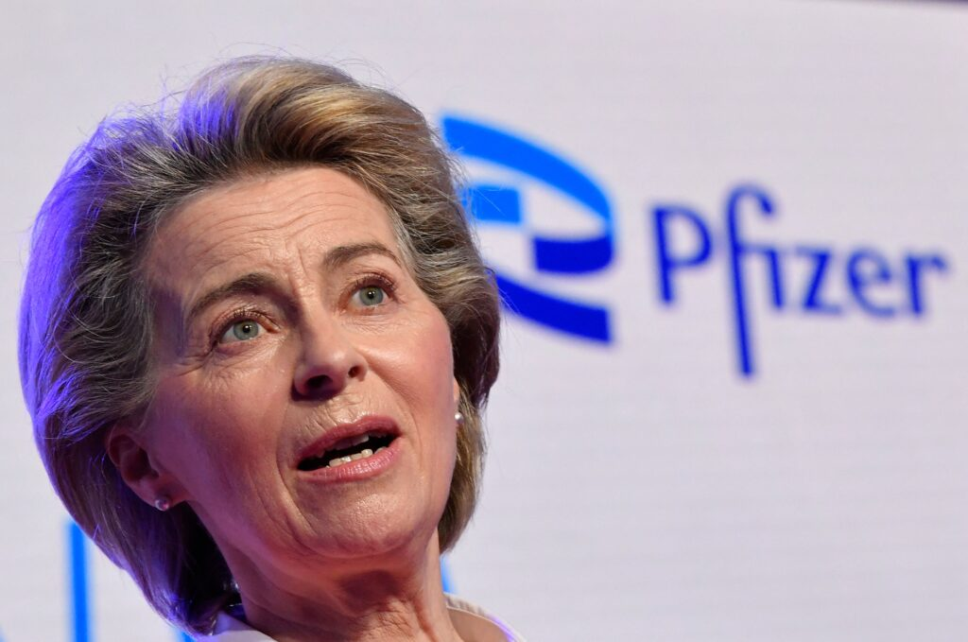Controversy has raged around the text messages supposedly exchanged between Commission President Ursula von der Leyen and Pfizer Chief Executive Albert Bourla | John Thys/AFP via Getty Images
The waste raises the question of why the Commission — with the support of national governments — signed onto so many doses so far in advance without any clause to back out based on the pandemic conditions, especially given the variability of the coronavirus waves that was already evident by April 2021.
EU officials have argued that it was a necessary insurance, and that it was better to spend money on doses that might be wasted than to need them and not have them. A coalition of Eastern and Central European countries sees things differently. They've clamored to renegotiate the contracts, as their finances have been battered by the energy shock of the Russian invasion of Ukraine coupled with an influx of refugees from across the border.

Burn after reading
Journalists, politicians, and watchdogs have all tried to shine a light on the unusual way the contract was negotiated, so far without success.
Alexander Fanta, a Brussels reporter at Netzpolitik, put in an "access to documents" request after reading the New York Times story. The Commission said it couldn't find the texts, earning a rap on the knuckles from the European Ombudsman.
The EU's budget watchdog, the European Court of Auditors, also came up against a wall of silence. In a report on the EU's vaccine procurement published September last year, the agency auditors said that unlike with other contract negotiations, the Commission refused to provide records of the discussions with Pfizer, either in the form of minutes, names of experts consulted, agreed terms, or other evidence.
Next it was the turn of the European Parliament. The committee on COVID-19, led by Belgian Socialist Kathleen Van Brempt, didn't fare any better that the auditors. Twice, Pfizer's CEO refused to appear in front of MEPs. And senior figures in the Parliament blocked a public cross-examination of the Commission president.
Even the New York Times, where von der Leyen first trumpeted her success, is now suing the Commission to have the text messages released.

Isn't it ironic
In theory, the Commission is still touting the contract as a success. In its public announcement Friday, it writes that "the implementation of our EU Vaccines Strategy exceeded all expectations." But the way the news was delivered speaks to a certain embarrassment.
The news came out on a Friday lunchtime ahead of a three-day weekend. There was no formal announcement during the Commission's daily briefing to journalists; instead a mention was tucked away in an emailed news roundup. These are not the hallmarks of an institution trying to make a news splash.
Asked about the decision not to disclose the revised total of doses, a detail that was disclosed in the original contract, a Commission spokesperson referred POLITICO to national governments. "Vaccine strategies or vaccine programs are designed and implemented by the member states," said the spokesperson.
Von der Leyen likely hopes that this latest deal puts the matter to bed, ahead of her likely run next year for a second term. With the pandemic officially over, and a public that wants to forget all about it, she might just get her wish.
But she's not quite out of the woods yet. The European Public Prosecutor's Office announced last October that it was looking into the EU's vaccine procurement. The financial crimes watchdog didn't say which contract it was looking at or whom it was investigating, but if it turns out that EPPO has the Commission president in its crosshairs, she may go from sure thing to has-been.

