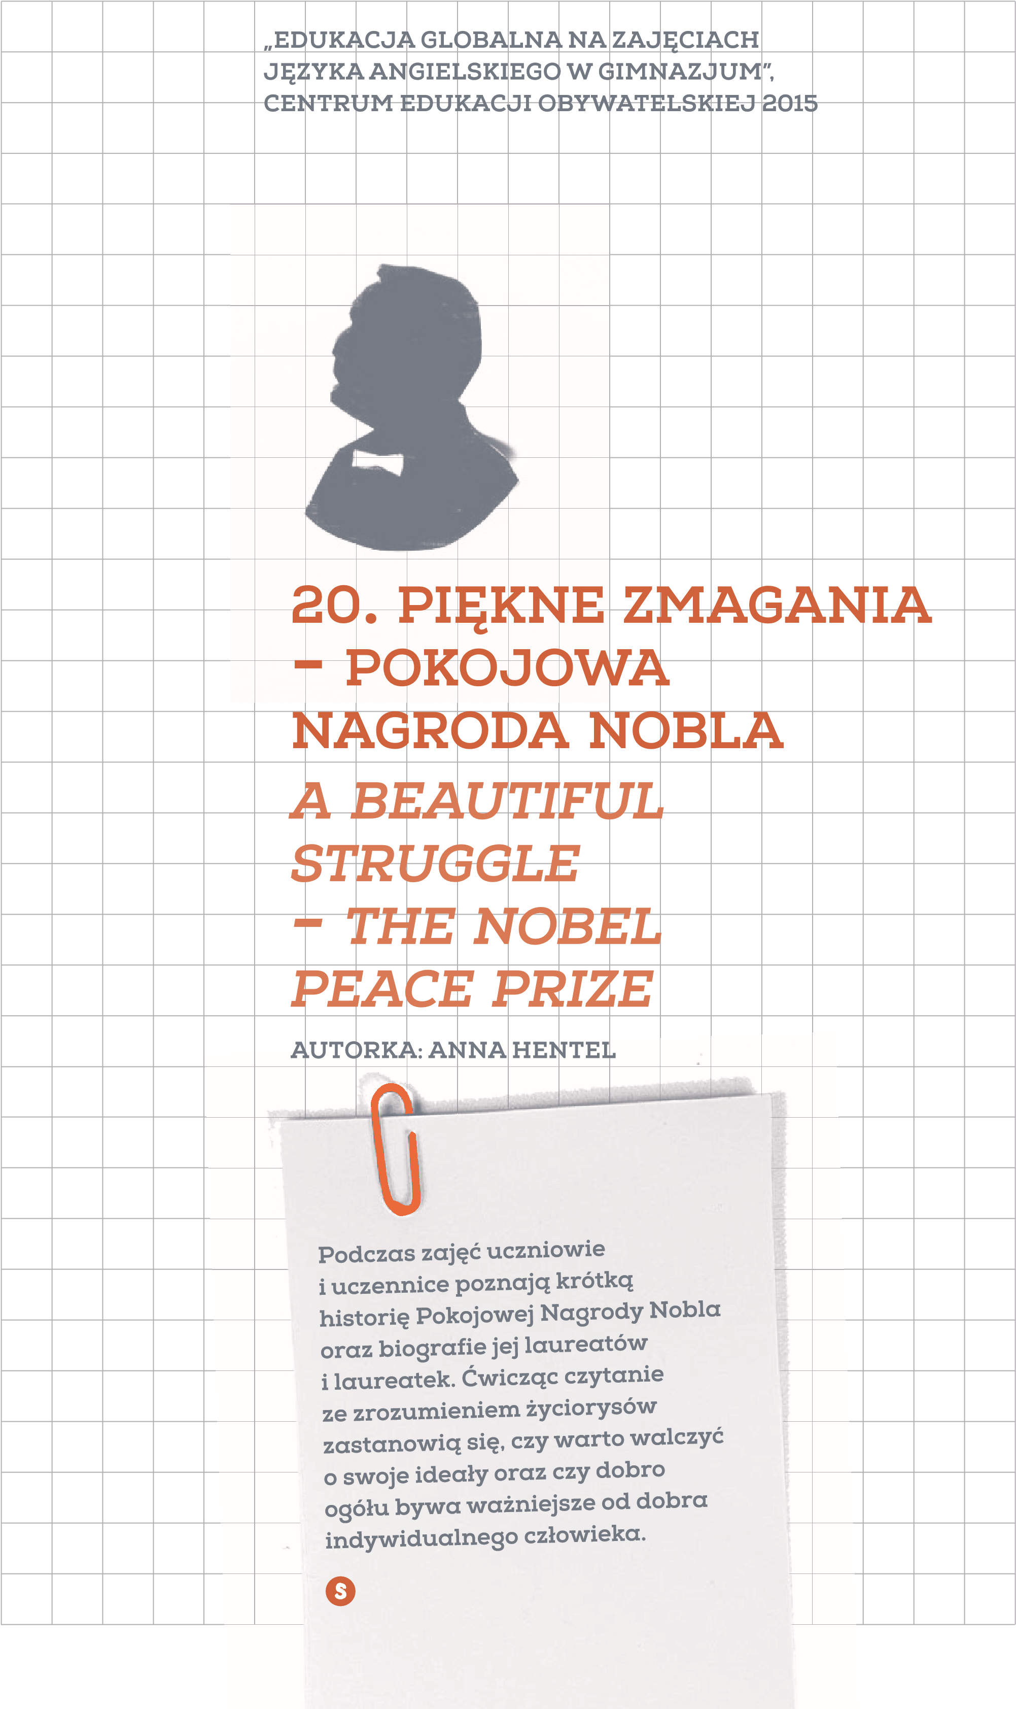
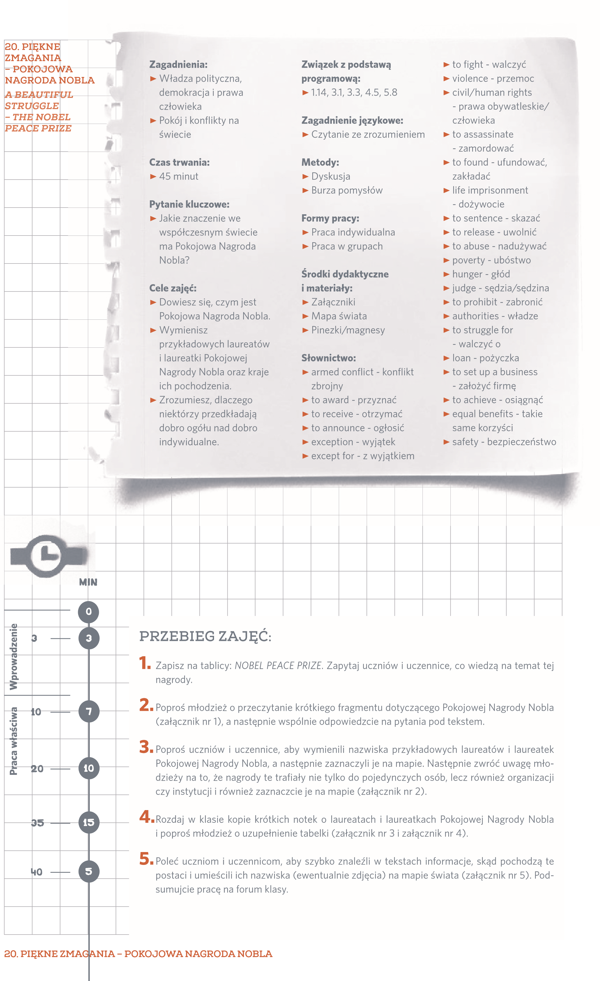
6
.
Zap
ytaj uczniów i uczennice o ich odczucia po zapoznaniu się z krótkimi informacjami o lau-
reatach i laureatkach Pokojowej Nagrody Nobla. Możesz zadać pytania pomocnicze. W tej
części pada odpowiedź na pytanie kluczowe.

Why did they receive the Nobel Peace Prize?

What do they have in common?

Why were most of them imprisoned?

,ŽǁĚŽƐƵĐŚƉĞŽƉůĞĂīĞĐƚƚŚĞƌĞƐƚŽĨƚŚĞǁŽƌůĚ͍

ĂŶƚŚĞŝƌĂĐƟŽŶƐƌĞƐƵůƚŝŶĂĐŚĂŶŐĞŝŶƚŚĞǁĂǇƉĞŽƉůĞƚŚŝŶŬ͍,Žǁ͍

tŚĂƚŵĞĂŶŝŶŐĚŽĞƐƚŚĞƉƌŝǌĞŚĂǀĞĨŽƌƚŚĞǁŽƌůĚƚŽĚĂǇ͍

/ƐŝƚŝŵƉŽƌƚĂŶƚƚŽŽƉƉŽƐĞŝŶũƵƐƟĐĞ͍
PRACA DOMOWA:

1
.
Zastanów się, komu ty przyznałbyś/abyś Pokojową Nagrodę Nobla i napisz dlaczego.
Podsumowanie
7:55
5
5
Załączniki:
Załącznik nr 1 -
Exercise: The Nobel Peace Prize
Załącznik nr 2 -
Nobel Peace Prize laureates – Organizations
Załącznik nr 3 -
Exercise: Profiles of the Nobel Peace Prize laureates
Załącznik nr 4 -
Exercise: Profiles of the Nobel Peace Prize laureates - The chart
Załącznik nr 5 -
Nobel Peace Prize laureates – Individuals
Źródło:
http://www.nobelprize.org/nobel_prizes/peace/
. PIĘKNE ZMAGANIA – POKOJOWA NAGRODA NOBLA
20

ZAŁĄCZNIK NR 1 – EXERCISE
THE NOBEL PEACE PRIZE
Read the passage and answer the questions below.
The Nobel Peace Prize is one of the five Nobel Prizes created by Alfred Nobel, who invented
dynamite. Until 2014 the members of the Norwegian Nobel Committee awarded the Peace Prize
to 128 Nobel Laureates since 1901. It is announced in the autumn every year with some excep-
tions. They have not given the prize on 19 occasions, for example during World Wars I and II. All
other Nobel Prizes are awarded in Stockholm, Sweden, but the Nobel Peace Prize is awarded in
Oslo, Norway, where the laureates receive the Nobel Medal, Nobel Diploma and a cheque in the
presence of the King of Norway. The Nobel Peace Prize goes to the person who helps to keep
friendship between nations, opposes wars and armed conflicts and promotes peace in the world.
QUESTIONS:

Who created the Nobel Peace Prize?

Who awards the Nobel Peace Prize?

How long has it been given?

,ŽǁŵĂŶǇƉĞŽƉůĞĂŶĚŽƌŐĂŶŝǌĂƟŽŶƐŚĂǀĞƌĞĐĞŝǀĞĚƚŚĞEŽďĞůWĞĂĐĞWƌŝǌĞ͍

Where is it awarded?

Who can receive the Nobel Peace Prize?
ZAŁĄCZNIK NR 2
NOBEL PEACE PRIZE
LAUREATES
– ORGANIZATIONS
United Nations, New York
European Union, Brussels
Doctors Without Borders, Geneva
Amnesty International, London
UNICEF, New York
The International Committee of the Red Cross, Geneva
ZAŁĄCZNIK NR 3 – EXERCISE
PROFILES OF THE NOBEL ^{PEACE P}RIZE LAUREATES
Read the profiles of the selected Nobel Peace Prize laureates.
Martin Luther King was born in 1929 and was killed in 1968. He was an American clergyman and activist, who fought against racism, poverty and war, especially against the Vietnam War. During his lifetime he organised many different protests but without violence. He was extremely famous for his speeches, one of which – I have a dream – helped to focus the US government on civil rights. He was so engaged in the African-American Civil Rights Movement that even after receiving the Nobel Peace Prize in 1964, as of then the youngest man in the history of the prize, he donated the money for this purpose. After he was assassinated on April 4, 1968 in Memphis, Tennessee, many more people protested against violence.

Born in 1918 Nelson Mandela was a politician, who became the first black president of South Africa from 1994 until 1999. As a student he lived in Johannesburg, where he started engaging into anti-colonial politics. Together with his friends he founded the Youth League which started a new era of leaders in South Africa. At the beginning Mandela organised non-violent protests which then changed into violent campaigns against the white government of South Africa. As a result, he was arrested and sentenced to life imprisonment. After spending over 27 years in prison, he was released in 1990 due to several international demands. During his lifetime he introduced laws against abusing human rights, focusing on charitable work in combating poverty and HIV/AIDS. He died on December 5, 2013 as an activist honoured with a big number of prizes, including the 1993 Nobel Peace Prize.

Shirin Ebadi is an Iranian lawyer who became the first female judge in the history of Iran. After the Iranian revolution in 1979 in which it was claimed that Islam prohibits women from becoming judges, she was not able to practice as a lawyer. For her lifetime she has been fighting against abuse of women and children as well as acting for democracy and civil rights for which she was awarded the Nobel Peace Prize in 2003. Since 2009 she has been living abroad (in the UK) like many other Iranians who are against the regime. She figures in a list of 100 most influential women of all time.

Liu Xiaobo is a Chinese writer and human rights activist, who called for a change in Chinese political system, which is based on communist one-party regime. For the first time he protested against China’s one-party system as a student and was sentenced to two years in prison. Since then he has fought for a more democratic China. In 2009 he was sentenced again to 11 years imprisonment for constant complaining about the state authorities. In 2010 he received the Nobel Peace Prize for his struggle for human rights. China censored the news about the award and Liu Xiaobo was not able to attend the award ceremony in Norway.

Muhammad Yunus is a Bangladeshi economist who developed a concept of microcredits – loans given to poor people wishing to set up their own business. He co-founded Yunus Social Business – Global Initiatives to solve social problems around the world. In 2006 he received the Nobel Peace Prize for combating extreme poverty.

Wangari Maathai, a Kenyan environmental and political activist, was born in 1940 and died in 2011. During her lifetime she campaigned for equal benefits for women. She founded Green Belt Movement, which resulted in creating new jobs, especially for women in nurseries. At the same time by the campaign of planting trees she opposed widening the deserts which led to increasing the level of poverty and hunger. She became the first African woman to receive the Nobel Peace Prize in 2004 for her activities.

Born in 1972 Leymah Gbowee is a Liberian peace activist who united women of different religions. In 2002 she organised a women’s peace movement that helped bring an end to the Liberian Civil War (thousands of women dressed in white were gathering to sing and pray for peace to stop the tyranny of Charles Taylor) and then helped elect Ellen Johnson-Sirleaf as the first female head of state in Africa. Leymah Gbowee was awarded the Nobel Peace Prize together with Ellen Johnson-Sirleaf and Tawakkul Karman for non-violent fight for the safety of women and women’s rights in 2011.

ZAŁĄCZNIK NR 4 – EXERCISE
PROFILES OF THE NOBEL
PEACE PRIZE LAUREATES
– THE CHART
Based on the texts from Excerise: Profiles of the Nobel Peace Prize Laureates, fill out the table below.
NAME | NATIONALITY | WHEN  AWARDED  THE NOBEL  PRIZE | ACTIVITY
Martin
Luther King
Nelson Mandela
Shirin Ebadi
Liu Xiaobo
Muhammad Yunus
Wangari Maathai
Leymah Gbowee
20. PIĘKNE ZMAGANIA – POKOJOWA NAGRODA NOBLA
ZAŁĄCZNIK N
R 5
NOBEL PEACE PRIZE
LAUREATES – INDIVIDUALS
Martin Luther King
Muhammad Yunus
Liu Xiaobo
Nelson Mandela
Leymah Gbowee
Wangari Maathai
Shirin Ebadi

