Imię i nazwisko: ________________________________________ Wynik: ______________ /58


ROZUMIENIE ZE SŁUCHU (0-12)
Audio 12 Zadanie 1 (4 punktów / _____ )
Usłyszysz dwukrotnie rozmowę na temat sportu. W zadaniach 1.1-1.4, na podstawie informacji zawartych w nagraniu, z podanych odpowiedzi wybierz właściwą. Zakreśl litery A, B albo C.
1.1 Angela wasn’t at school because she
A played in a tennis tournament
B was ill
C met with Arthur
1.2 The girl who did not play basketball was
A Tina
B Sandra
C Melanie
1.3 Eric hurt his leg while
A doing some sports
B trying on new clothes
C walking in a shopping centre
1.4 The speakers want to
A complain about their friends
B tell each other about their weekends
C share the latest news about people they know
Audio 13 Zadanie 2 (4 punkty / ______ )
Usłyszysz dwukrotnie wypowiedź na temat centrów handlowych. Na podstawie informacji zawartych w nagraniu uzupełnij luki 2.1–2.4 w poniższej notatce. Luki należy uzupełnić w języku angielskim.
SHOPPING MALLS
- In the Dubai Mall you can go to the world’s biggest 2.1 __________________.
- Mall of America is visited by 2.2 ________________ people every year.
- The largest shopping mall in the world is in 2.3 _____________.
- Not many people visit the New South China Mall because it’s 2.4 __________________ there.

Audio 14 Zadanie 3 (4 punkty / ______ )
Usłyszysz dwukrotnie cztery wypowiedzi. Na podstawie informacji zawartych w nagraniu dopasuj do każdej wypowiedzi 3.1–3.4 odpowiadające jej zdanie (A–E). Wpisz rozwiązania do tabeli. Uwaga! Jedno zdanie zostało podane dodatkowo i nie pasuje do żadnej wypowiedzi.
This speaker:
A isn’t happy about his/her situation
B is an immigrant
C lives in a dangerous neighbourhood
D used to be a politician
E was a victim of bullying
3.1 | 3.2 | 3.3 | 3.4

ZNAJOMOŚĆ FUNKCJI JĘZYKOWYCH (0-10)
Audio 15 Zadanie 4 (4 punkty / ______ )
Usłyszysz dwukrotnie cztery wypowiedzi (4.1–4.4). Do każdej z nich dobierz właściwą reakcję A–E. Wpisz rozwiązania do tabeli. Uwaga! Jedna reakcja została podana dodatkowo i nie pasuje do żadnej wypowiedzi.
A Italian dishes are my favourite.
B It’s great, but really demanding.
C I want to get a weekend job.
D Well, I think my job is well-paid.
E At the florist’s, I love flowers.
4.1 | 4.2 | 4.3 | 4.4

Zadanie 5 (3 punkty / ______ )
Uzupełnij minidialogi 5.1–5.3. Wpisz w każdą lukę brakujący fragment wypowiedzi, tak aby otrzymać spójne i logiczne teksty. Luki należy uzupełnić w języku angielskim.
5.1 X: This box is so heavy! Could you give ______________________ with it?
Y: Sure, I’ll carry it with you.
X: Thanks a lot.
5.2 X: Tom, you don’t look well. What _______________________________?
Y: I feel sick, I think I have to go to the bathroom.
5.3 X: Hi, I’d like to try on these jeans. Where _____________________________ ?
Y: They’re over there, in the corner.
X: Thanks.

Zadanie 6 (3 punkty / ______ )
Uzupełnij dialog. Wpisz w każdą lukę (6.1–6.3) brakujący fragment wypowiedzi, tak aby otrzymać spójny i logiczny tekst. Wykorzystaj wyrazy podane w nawiasach, ale nie zmieniaj ich formy. Luki należy uzupełnić w języku angielskim.

Anne So how did you like the film?
Patrick It was great. The best picture I’ve seen in years.
Anne Really? I 6.1 (agree) ____________________. In my opinion it was rubbish. The plot was unoriginal and the acting was poor.
Patrick Hmm, I see what you mean, but I 6.2 (opinion) ________________________________. What about you, Bob? What did you think of it?
Bob I didn’t like it very much, but it was OK, I guess. It was a nice way to spend an evening.
Anne All right, and do you 6.3 (feel) ____________________________ a hamburger now? I’m starving.
Patrick Sure, why not? Great films always make me hungry.

ROZUMIENIE TEKSTÓW PISANYCH (0-15)
Zadanie 7 (4 punkty / ______ )
Przeczytaj teksty. W zadaniach 7.1–7.4 z podanych odpowiedzi wybierz właściwą, zgodną z treścią tekstów. Zakreśl literę: A, B albo C.
Tekst 1
Greenbridge General Hospital gave Princess Louise a warm welcome on Friday when she opened the new children’s ward. The princess spent twenty minutes chatting to patients. Ten-year-old Nancy Davis, who is recovering from an eye operation, presented her with a bouquet of flowers.

Tekst 2
There were quite big crowds out, waiting to see the princess go past. She kept stopping to chat, and several children stepped forward with flowers for her. The walkabout lasted about ten minutes and then went off to the public library, right next to the new hospital, where the princess read books to children.

7.1 Both texts are about
A a royal visit.
B a new hospital ward.
C an opening ceremony.
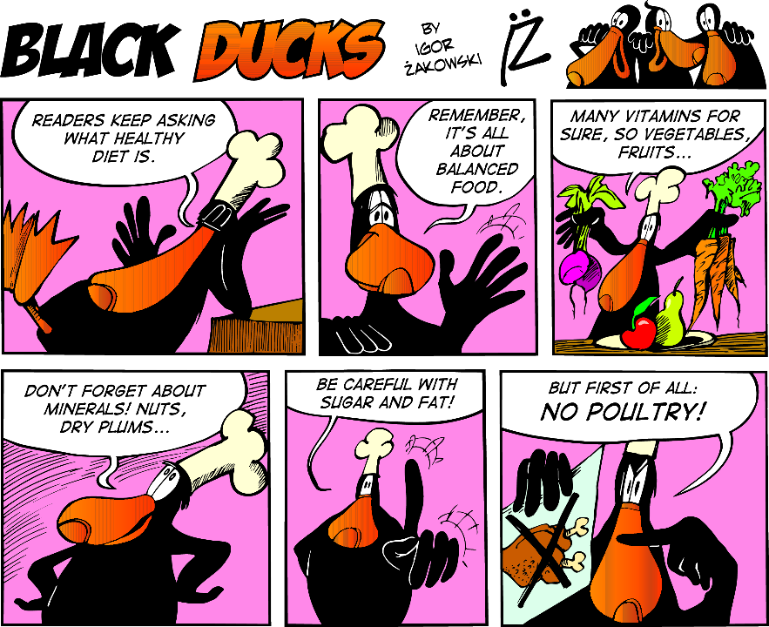
7.2 This text is
A a recipe for a dish made of duck.
B a story of how a duck became a chef.
C a set of instructions about healthy eating.
Police report
The suspect said that he was innocent and that he hadn’t done anything. He also stated that he had spent last night at home. Then he asked if there was any evidence against him. After
I showed him the photos from the security camera, he finally said he would tell us everything. He only asked us not to tell anything to his mother.

7.3 The suspect did not
A ask the policemen a favour.
B ask the policeman a question.
C say what crime he committed.
Hi Derek,
1 Or you can take pictures of your notes and send them to me.
2 I need to catch up so could you please bring me your notebooks?
3 I’m feeling better, thanks for asking, and I hope to be back at school next week.
4 Could you do me a favour?
Thank you!
See you soon,
Paula

7.4 The correct order of the sentences in the message is:
A 4 - 3 - 2 - 1
B 3 - 4 - 2 - 1
C 2 - 1 - 4 - 3
Zadanie 8 (4 punkty / ______ )
Przeczytaj teksty na temat trzech wynalazków (A–C) oraz zdania 8.1–8.4. Do każdego zdania dopasuj właściwy tekst. Wpisz rozwiązania do tabeli. Uwaga! Jeden tekst pasuje do dwóch zdań.
This invention
8.1 | is ancient.
8.2 | was first tested on animals.
8.3 | was thought to be dangerous.
8.4 | has made a big difference in one continent.
A
A simple design by British inventor Trevor Baylis is probably one of the world’s most important inventions. In 1991 he invented a radio that doesn’t have a battery. It has a handle that you turn by hand. He designed this ‘wind-up radio’ especially for parts of Africa where communication is difficult. Baylis has never made much money from his invention although it is now used all over Africa and has changed millions of lives.
B
The first ‘flying machines’ were hot air balloons. They were invented by two French brothers (the Montgolfier brothers). In 1783 a crowd of people, including the King, watched as a sheep, a duck and a cock became the first living things to fly. They went up to a height of 460 metres and landed safely. Nobody had been sure if they would be able to breathe. After the success of that test, the first human flight soon followed.
C
Of course, the wheel is one of the most important inventions of all time. It is more than five thousand years old, and it’s hard to imagine life without it. Transport is a good example: people have travelled by wheel since at least 2000BC. The invention seems such a simple idea to us, it’s amazing to think that the Aztecs managed just fine without it.

Zadanie 9 (3 punkty / ______ )
Przeczytaj teksty 1 i 2. Uzupełnij luki 9.1–9.3 w emailu do Kate zgodnie z treścią tekstów. Luki należy uzupełnić w języku angielskim.

Tekst 1
In War for the Planet of the Apes, Caesar (played by Andy Serkis) and his apes are forced into a deadly conflict with an army of humans led by a hard-hearted Colonel (played by Woody Harrelson). Eventually, Caesar and the Colonel must fight with each other in an epic battle that will determine the fate of both their species and the future of the planet. But what a wonderful surprise to see how much this movie is centred on its characters and not only on the action (after all, there is a ‘war’ in the title), so it is also a film for intelligent drama lovers.

Tekst 2
●○○ Your Browser


https://www.yourcinema.com
Title Type Hours Length
War for the Planet of the Apes sci-fi 15:10, 18:00 140 min.
Me Before You love story 14:30, 17:30 110 min.
The Bourne Identity action 16:00, 19:30 118 min.
The Incredibles animated 12:30, 15:00 115 min.
New message

From: June Osmond
To: Kate Stephenson
Subject: Cinema!

Hi Kate,
Do you still remember you promised to go to the cinema with me this weekend? I can’t wait!
I know love stories are your favourite, but maybe we could see War for the Planet of
the Apes? It is a 9.1 ________________ film, although it has also got a lot of action
and some drama, which you will probably enjoy :). It’s basically about a war between
the apes and the 9.2 ______________, but I’ve seen the trailer and the special effects are amazing! I finish my basketball practice at 5pm, so we could go for the film show at 6 p.m.
I know it’s a 9.3 _______________ film and that it finishes late, but I can ask my dad
to pick us up afterwards.
Let me know what you think.
Best,
June

Zadanie 10 (4 punkty / ______ )
Przeczytaj tekst. Uzupełnij luki w zdaniach 10.1–10.4 zgodnie z treścią tekstu. Luki należy uzupełnić w języku angielskim.
Smallpox
In the early 18th century, smallpox was one of the biggest causes of death in Europe. The wife of the British ambassador to Turkey, Lady Montagu nearly died
of the disease. She eventually got better but her brother wasn’t so lucky. He didn’t survive. While she was in Turkey, she discovered a way to stop the disease. Doctors there gave people a small amount of the disease. They did this so that their patients could then fight it. When Lady Montagu returned to England, she tried to tell people about the Turks’ treatment of smallpox. People didn’t listen to her, even doctors weren’t interested. This was partly because she was a woman and partly because
the idea was ‘eastern’. However, her own doctor had seen how effective the Turk’s treatment was. He wrote a scientific article on the subject and the idea soon became more popular. Fifty years later, a scientist, Edward Jenner, discovered an even safer and better treatment. It is his name we still remember today. Thanks to his work, the disease was brought under control. However, he couldn’t have done it without Lady Montagu and, above all, the Turks.
10.1 Lady Montagu’s brother _____________ of smallpox.
10.2 Lady Montagu found out that doctors in _______________ know how to fight smallpox.
10.3 She told people in England about the treatment, but only ________________ listened to her.
10.4 50 years later Edward Jenner made the treatment ____________________.

ZNAJOMOŚĆ ŚRODKÓW JĘZYKOWYCH (0-11)
Zadanie 11 (3 punkty / ______ )
Przeczytaj tekst. Spośród wyrazów podanych w ramce wybierz te, które są poprawnym uzupełnieniem luk 11.1–11.3. Wpisz odpowiednią literę A–F obok numeru każdej luki. Uwaga! Trzy wyrazy zostały podane dodatkowo i nie pasują do żadnej luki.
A amazed | B invented | C watched | D amazing | E looked | F discovered
The computer mouse
The first computer mouse was 11.1___________ in 1964 by Douglas Engelbart and it was a little wooden box on wheels. It was called a mouse because it was connected to the computer with
a wire which 11.2___________ like a tail. Nowadays, there are a lot of different types of mice
and most people use wireless ones – without a tail. Their purpose is still the same and it’s
an 11.3___________ piece of equipment which we need when we use a computer.

Zadanie 12 (4 punkty / ______ )
Wykorzystując wyrazy podane drukowanymi literami, uzupełnij każde zdanie z luką, tak aby zachować sens zdania wyjściowego (12.1–12.4). Wymagana jest pełna poprawność ortograficzna i gramatyczna wpisywanych fragmentów zdań. Uwaga! Nie zmieniaj formy podanych wyrazów. W każdą lukę możesz wpisać maksymalnie trzy wyrazy, wliczając w to wyraz już podane.
12.1 Thomas Edison invented the light bulb.
BY
The light bulb ______________________________ Thomas Edison.

12.2 Could you help me carry these bags to the car?
COULD
I wonder _______________________ help me carry these bags to the car.
12.3 I hope the weather is good tomorrow and we can drive to the lake.
RAIN
If it _______________________ tomorrow, we can drive to the lake.
12.4 It was raining and Jeff took the bus home because he didn’t want to get wet.
SO
It was raining and Jeff took the bus home _____________________ to get wet.

Zadanie 13 (4 punkty / ______ )
Przeczytaj opis ilustracji. Uzupełnij każdą lukę (13.1–13.4) jednym wyrazem tak, aby powstał spójny i logiczny tekst zgodny z ilustracją. Wymagana jest pełna poprawność ortograficzna i gramatyczna wpisywanych wyrazów.

This is a picture of a woman and a man who are shopping. They look like a couple. The woman’s got long, 13.1 ______________, brown hair and she’s probably wearing a dress. She’s carrying two
13.2 ________________. She’s pointing her finger at something and she’s 13.3 ________________, so she must be very happy. The man’s got short hair and he’s wearing a T-shirt and a shirt on top
of it. He looks 13.4 _________________ and he definitely does not enjoy what he’s doing.

WYPOWIEDŹ PISEMNA
Zadanie 14 (10 punktów / ______ )
Podczas zakupów w centrum handlowym w Londynie byłeś/aś świadkiem wydarzenia z udziałem policji. Podziel się swoimi wrażeniami na ten temat na swoim blogu:
- napisz, co robiłeś/aś w centrum, gdy doszło do wydarzenia,
- opisz to wydarzenie,
- napisz jak się teraz czujesz odnośnie wydarzenia.
Napisz swoją wypowiedź w języku angielskim. Podpisz się jako XYZ. Rozwiń swoją wypowiedź
w każdym z trzech podpunktów, tak aby osoba nieznająca polecenia w języku polskim uzyskała wszystkie wskazane w nim informacje. Pamiętaj, że długość wypowiedzi powinna wynosić od 50
do 120 słów (nie licząc wyrazów podanych na początku wypowiedzi). Oceniane są: umiejętność pełnego przekazania informacji, spójność, bogactwo językowe oraz poprawność językowa.
Me, Myself and I Blog
30 minutes ago
Hi! Today I want to tell you about an incident I witnessed in a shopping mall in London.
..……………………………………………………………………………………………………………………….…………….
…………………………………………………………………………………………………………………………………..……
………………………………………………………………………………………………………………………..………………
……………………………………………………………………………………………………………………………..…………
………………………………………………………………………………………………………………………..………………
………………………………………………………………………………………………………………………..………………
………………………………………………………………………………………………………………………………..…………………………………………………………………………………………………………………………………..……………
And what do you think about it? Share your opinions in the comments.

