Vocabulary
- Dopasuj nazwy programów telewizyjnych do obrazków.
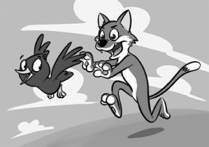  a | 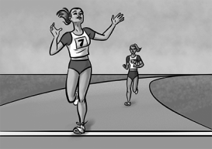  b | 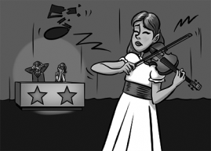  c
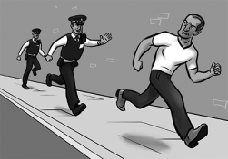  d | 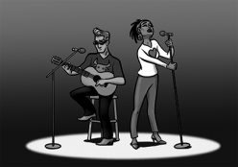  f  e | 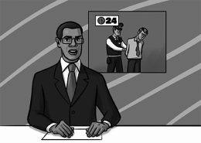  f
news 3 police drama
1 music show 4 cartoon
2 sports programme 5 talent show
5

Grammar
- Zakreśl poprawne formy czasu past simple.
I _______ to London last year.
a went b goed
1 We _______ a lot of things together.
a doed b did
2 I _______ Jake at the cinema.
a meeted b met
3 Lizzy _______ with Ben at the party.
a spoke b speaked
4 Carl and Sandy _______ this morning.
a leaved b left
5 Roy _______ a lot of mistakes.
a made b maked
5

- Zakreśl właściwe zaimki pytające.
What / Where did you do last night?
1 When / Where did you go after school?
2 Who / Why did Sophie talk to at the party?
3 What / Why didn’t you do your homework?
4 What / Where did you eat for lunch?
5 When / What did the film start?
5
Reading
- Przeczytaj tekst. Zaznacz odpowiednio T (prawda) lub F (fałsz).
Yesterday, I got up early and made a packed lunch. Then, I took the bus to town. I met Ellie at the museum at eleven o’clock. We spent two hours there. Then we went to the park and had our lunch. We took lots of photos with our mobile phones. At about half past two, we went to the cinema. We saw the new Leonardo DiCaprio film. It was fantastic. After the film, we walked to the train station and came home by train. In the evening, Ellie stayed at my house for dinner. My mum made pizzas for us. Ellie’s dad came for her at about seven o’clock. We had a great day.
Kitty Evans

T F

Kitty and Ellie had lunch in the park.
1 They spent an hour in the park.
2 They took photos with their phones.
3 After the film, they took the train home.
4 Kitty’s mum cooked dinner for them.
5 Ellie went home at about six o’clock.

5

20

