Vocabulary
- Przyjrzyj się obrazkom i zakreśl właściwą literę.
D
C
B
A
 | 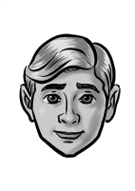 |  | 
He’s got spiky hair. A / B
    - He hasn’t got any hair. A / C
    - He’s got a beard. B / D
    - He’s got a moustache. C / D
    - He’s got blonde hair. A / B
    - He’s got black hair. A / B
5

- Podpisz elementy ilustracji.
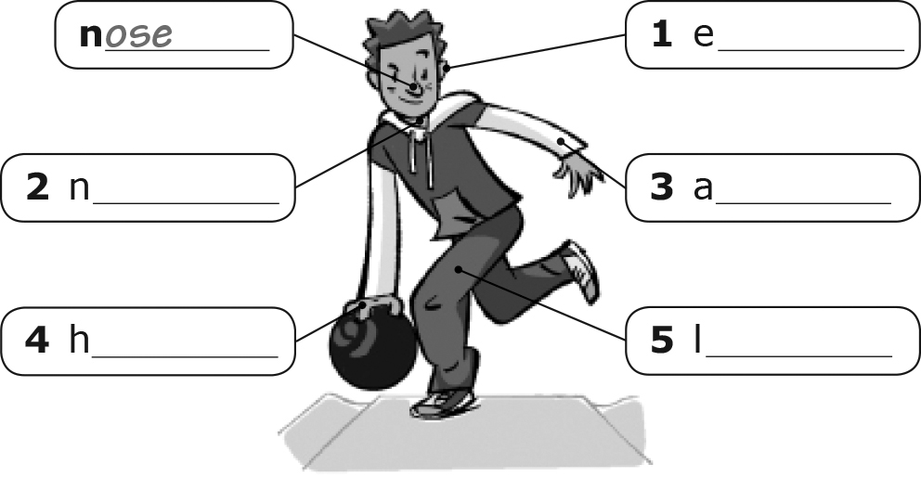
5
Grammar
- Uzupełnij zdania podanymi czasownikami w czasie present continuous.
Macy _is sitting_ on my chair. (sit)
    - Mike and Johnny _______________ in the garden today. (study)
    - He _______________ a postcard to
his grandad. (write)
    - Sam and I _______________ in
the park. (run)
    - The car _______________ in front of
our house. (stop)
    - I _______________ with Emily. (dance)

5

- Napisz krótkie odpowiedzi.
Is Paul playing the guitar with his band? ✓
Yes, he is.___________________________
    - Is your phone ringing? ✓
____________________
    - Are the girls doing their homework? ✗
____________________
    - Are you writing an email to Alex? ✓
____________________
    - Is Martina winning the tennis tournament? ✗
____________________
    - Are you and your brother watching TV? ✓
___________________________________

5
- Zakreśl właściwy wyraz.
Where is my / mine phone?
    - This book is Carla’s. The pen is her / hers, too.
    - These aren’t their / theirs books.
    - Our / Ours pizza is getting cold.
    - These CDs are my / mine.
    - Where are you, Jamie? Your / Yours dad is on the phone.
5
Reading
- Przeczytaj tekst. Zaznacz odpowiednio T (prawda) lub F (fałsz).
It’s a beautiful day today so we’re in the park. Matty and Paul are playing football with two very tall German boys from a group of tourists. The girls are eating sandwiches, but Kathy isn’t happy because hers isn’t very good. She only likes tomato sandwiches and the shop hasn’t got those. Ben and Mark are talking about football. Some small children are playing with a ball. They’re having a great time. Their parents are taking photos with their mobile phones.
T F

It’s raining.
    - Matty and Paul are playing football
with two German tourists.
    - The girls are having ice creams.
    - Kathy is eating a tomato sandwich.
    - Some small children are playing
in the park.
    - The children’s parents are talking.

5
Communication
- Dopasuj pytania do odpowiedzi.
c
Could I borrow this DVD, please?
    - Can I borrow your bike?
    - Can I use your laptop?
    - Can I have an ice cream, Mum?
    - Can we go out in the garden?
    - Could I close the window, please?

    - No, you can’t. It’s lunch time.
    - Do your homework now. You can
go out later.
    - Yes, you can. It’s a great film!
    - No, you can’t. It’s very hot in here.
    - Yes, you can. It’s out in the garden.
    - Not now. I’m writing an email.
5

Writing
- Wybierz z ramki pięć zwrotów i ułóż z nimi pięć zdań w czasie present continuous o tym, co teraz robisz.
do an English test sit in my chair
write with a pencil wear jeans
wear a T-shirt eat a sweet
write with a pen wear blue socks
use a dictionary

I ’m using a dictionary________________.
    - I _________________________________.
    - My friend and I ______________________.
    - I _________________________________.
    - I _________________________________.
    - My English teacher ___________________.
5

Poprawa kartkówki:
1 Uzupełnij zdania czasownikami w czasie present continuous.
1 Julia ____________________ a magazine. (read)
2 We ____________________ TV. (watch)
3 You ____________________ lunch. (cook)
4 I ____________________ in the park. (run)
5 Stan and Alfred ____________________ in the pool. (swim)
2 Uzupełnij zdania właściwymi zaimkami.
1 That is my brother's car. The car is _______________.
2 This sandwich is for me. The sandwich is _______________.
3 Those books are for the new students. The books are _______________.
4 Our family lives in this house. The house is _______________.
5 That is my sister's phone. The phone is _______________.

