fffffffffffffffffffffffffffffffffffffffffffffffffffffffffffff ffffffffffffffffffffffff ttttttttttttttttttttttttttttttttttttttt fffffffffffffffffffffffffffffffffffffffffffffffffffffffffffffffffffffffffffffffffffffffffffffffffffff hhhhhhhhhhhhhhhhhhhhhhhhhhhhhhhhhhhhhhhhhhhhhhhhhhhhhhhhhhhhhhhhhh fffffffffffffffffffffffffffffffffffffffff mmmmmmmmmmmmmmmmmmmmmmmmmmmmmmmmmmmmm
fffffffffffffffffffffffffffffffffffffffffffffffffffffffffffff ffffffffffffffffffffffff ttttttttttttttttttttttttttttttttttttttt fffffffffffffffffffffffffffffffffffffffffffffffffffffffffffffffffffffffffffffffffffffffffffffffffffff hhhhhhhhhhhhhhhhhhhhhhhhhhhhhhhhhhhhhhhhhhhhhhhhhhhhhhhhhhhhhhhhhh fffffffffffffffffffffffffffffffffffffffff 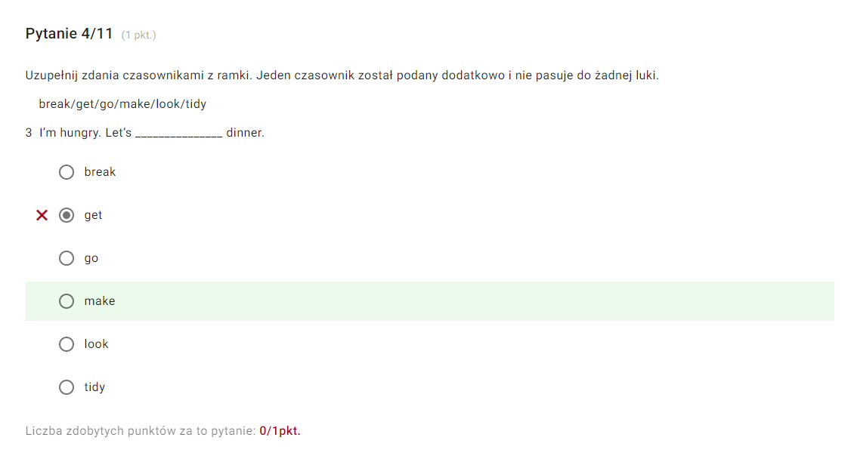mmmmmmmmmmmmmmmmmmmmmmmmmmmmmmmmmmmmm
fffffffffffffffffffffffffffffffffffffffffffffffffffffffffffff ffffffffffffffffffffffff ttttttttttttttttttttttttttttttttttttttt fffffffffffffffffffffffffffffffffffffffffffffffffffffffffffffffffffffffffffffffffffffffffffffffffffff hhhhhhhhhhhhhhhhhhhhhhhhhhhhhhhhhhhhhhhhhhhhhhhhhhhhhhhhhhhhhhhhhh fffffffffffffffffffffffffffffffffffffffff mmmmmmmmmmmmmmmmmmmmmmmmmmmmmmmmmmmmm
fffffffffffffffffffffffffffffffffffffffffffffffffffffffffffff ffffffffffffffffffffffff ttttttttttttttttttttttttttttttttttttttt fffffffffffffffffffffffffffffffffffffffffffffffffffffffffffffffffffffffffffffffffffffffffffffffffffff hhhhhhhhhhhhhhhhhhhhhhhhhhhhhhhhhhhhhhhhhhhhhhhhhhhhhhhhhhhhhhhhhh fffffffffffffffffffffffffffffffffffffffff mmmmmmmmmmmmmmmmmmmmmmmmmmmmmmmmmmmmm
fffffffffffffffffffffffffffffffffffffffffffffffffffffffffffff ffffffffffffffffffffffff ttttttttttttttttttttttttttttttttttttttt fffffffffffffffffffffffffffffffffffffffffffffffffffffffffffffffffffffffffffffffffffffffffffffffffffff hhhhhhhhhhhhhhhhhhhhhhhhhhhhhhhhhhhhhhhhhhhhhhhhhhhhhhhhhhhhhhhhhh fffffffffffffffffffffffffffffffffffffffff mmmmmmmmmmmmmmmmmmmmmmmmmmmmmmmmmmmmm
fffffffffffffffffffffffffffffffffffffffffffffffffffffffffffff ffffffffffffffffffffffff ttttttttttttttttttttttttttttttttttttttt fffffffffffffffffffffffffffffffffffffffffffffffffffffffffffffffffffffffffffffffffffffffffffffffffffff hhhhhhhhhhhhhhhhhhhhhhhhhhhhhhhhhhhhhhhhhhhhhhhhhhhhhhhhhhhhhhhhhh fffffffffffffffffffffffffffffffffffffffff mmmmmmmmmmmmmmmmmmmmmmmmmmmmmmmmmmmmm
fffffffffffffffffffffffffffffffffffffffffffffffffffffffffffff ffffffffffffffffffffffff ttttttttttttttttttttttttttttttttttttttt fffffffffffffffffffffffffffffffffffffffffffffffffffffffffffffffffffffffffffffffffffffffffffffffffffff hhhhhhhhhhhhhhhhhhhhhhhhhhhhhhhhhhhhhhhhhhhhhhhhhhhhhhhhhhhhhhhhhh fffffffffffffffffffffffffffffffffffffffff mmmmmmmmmmmmmmmmmmmmmmmmmmmmmmmmmmmmm

