Write a short text for kids, describing the White House (about 150 words)

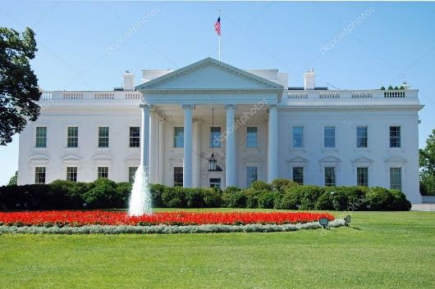
The White House is the official residence and workplace of the president of the United States. It is located at 1600 Pennsylvania Avenue NW, Washington, DC, 20500. The White House is one of the most well-known sites in Washington, D.C. It has 132 rooms, 35 bathrooms, 412 doors, and 147 windows. The walls of the White House are made of sandstone and painted white.
The president of the United States lives and works in the White House. The president's family also lives there. The White House has a rich history. It was built by immigrants, African-American laborers (enslaved and free), and Europeans. The first president to live in the White House was John Adams. Over the years, several presidents and their wives have redecorated the rooms of the White House.
The White House is not only a home but also a place where important decisions are made. It has its own doctor's office, dentist's office, barber shop, movie theater, swimming pool, tennis court, jogging track, and library. The public can tour parts of the main building to learn more about its history and significance.
Please note that visiting hours may vary, so it's best to check before planning a visit.
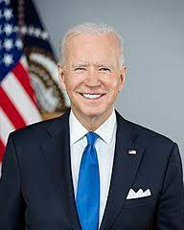
Joe Biden is the President of the United States of America.

Here’s a quiz based on the description of the White House:
- What is the official residence and workplace of the president of the United States?
- Where is the White House located?
- How many rooms are there in the White House?
- How many doors are there in the White House?
- What are the walls of the White House made of?
- Who was the first president to live in the White House?
- What are some facilities available in the White House?
- Can the public visit the White House?
- What should you do before planning a visit to the White House?
- Who can live in the White House apart from the president?
I hope you enjoy answering these questions! Let me know if you need any further assistance.

Simplified text:
The White House is the president of the United States' official residence and workplace. It is located at 1600 Pennsylvania Avenue NW in Washington, D.C. It is one of the most famous landmarks in the city.
The White House has 132 rooms, 35 bathrooms, 412 doors, and 147 windows. The walls are made of sandstone and painted white.
The president, their family, and staff live and work in the White House. It also has a doctor's office, dentist's office, barber shop, movie theater, swimming pool, tennis court, jogging track, and library.
The public can tour parts of the White House to learn more about its history and significance. Visiting hours may vary, so it's best to check before planning a visit.

https://www.youtube.com/live/mzCc5yX9soY?si=_8YIAukjvpkePySZ
https://youtu.be/BG9Cw5F3ews?si=IMISDZFAPIKY0VYm

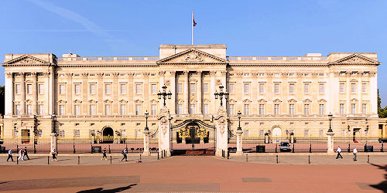
Buckingham Palace is a royal residence located in the City of Westminster, London. It serves as the administrative headquarters for the monarch of the United Kingdom. The palace is often at the center of state occasions and royal hospitality. It has been a focal point for the British people during times of national rejoicing and mourning.
Originally known as Buckingham House, the building was constructed in 1703 as a large townhouse for the Duke of Buckingham. It was acquired by King George III in 1761 as a private residence for Queen Charlotte and became known as The Queen's House. Over time, it was expanded by architects John Nash and Edward Blore, who constructed three wings around a central courtyard¹.
Buckingham Palace became the London residence of the British monarch when Queen Victoria ascended to the throne in 1837. The palace has 775 rooms, and its garden is the largest private garden in London. The state rooms, used for official and state entertaining, are open to the public each year for most of August and September and on some days in winter and spring.
"The palace is a grand symbol of British history and culture. It's where kings and queens have lived for centuries!"
"Did you know that Buckingham Palace has its own guard? They're called the Queen's Guard, and they're famous for their red uniforms and tall black hats!"
"The palace is also home to some amazing treasures, like paintings, sculptures, and even a throne!"
"If you ever visit London, make sure to stop by Buckingham Palace. You might even get to see the Changing of the Guard ceremony!"
"It's a truly magical place that will make you feel like royalty!"

Here’s a quiz based on the description of the Buckingham Palace:
1. What is Buckingham Palace?
2. Who was the palace originally built for?
3. Who acquired the palace in 1761?
4. What is the name of the private garden at Buckingham Palace?
5. When did Buckingham Palace become the London residence of the British monarch?
6. How many rooms does Buckingham Palace have?
7. When are the state rooms open to the public?
8. What is the name of the guard at Buckingham Palace?
9. What is the color of their uniform?
10. What is the name of the organization that manages Buckingham Palace?

Simplified text:
Buckingham Palace is the main residence and administrative headquarters of the British monarch in London. It is a symbol of British history and culture.
Originally known as Buckingham House, the building was constructed in 1703 as a large townhouse for the Duke of Buckingham. It was acquired by King George III in 1761 as a private residence for Queen Charlotte and became known as The Queen's House. Over time, it was expanded by architects John Nash and Edward Blore, who constructed three wings around a central courtyard.
Buckingham Palace became the London residence of the British monarch when Queen Victoria ascended to the throne in 1837. The palace has 775 rooms, and its garden is the largest private garden in London. The state rooms, used for official and state entertaining, are open to the public each year for most of August and September and on some days in winter and spring.
Fun facts:
Buckingham Palace has its own guard, called the Queen's Guard. They are famous for their red uniforms and tall black hats.
The palace is also home to some amazing treasures, like paintings, sculptures, and even a throne.
If you ever visit London, make sure to stop by Buckingham Palace. You might even get to see the Changing of the Guard ceremony!
Conclusion:
Buckingham Palace is a truly magical place that will make you feel like royalty.

Buckingham Palace is more than 300 years old. It is very big with 775 rooms, including 240 bedrooms and 78 bathrooms. There are also 92 offices. About 450 people work at the palace. There are chefs, electricians,
gardeners, drivers, cleaners and two people who look after the 350 clocks! Every year, over
50,000 people visit the Queen for dinners and garden parties.
Inside the palace, there's a cinema, a swimming pool, a doctor's surgery, a post
office and a police station. On the walls, there is an amazing collection of art. Underneath
the palace, there are a lot of secret tunnels! Outside, the gardens are huge and beautiful.
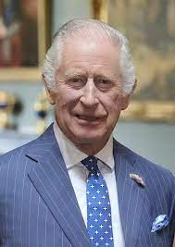
There are tennis courts, a boating lake and also a helicopter pad.
Charles III is the King of the United Kingdom.

Buckingham Palace Quiz

- How old is Buckingham Palace?
More than 300 years
- How many rooms does Buckingham Palace have?
775
- How many bedrooms does Buckingham Palace have?
240
- How many bathrooms does Buckingham Palace have?
78
- How many offices does Buckingham Palace have?
92
- How many people work at Buckingham Palace?
About 450
- What are some of the jobs that people have at Buckingham Palace?
Chefs, electricians, gardeners, drivers, cleaners, and people who look after the clocks
- How many people visit the Queen for dinners and garden parties each year?
Over 50,000
- What are some of the things that you can find inside Buckingham Palace?
A cinema, swimming pool, doctor's surgery, post office, police station, and an amazing collection of art
- What are some of the things that you can find outside Buckingham Palace?
Huge and beautiful gardens, tennis courts, a boating lake, and a helicopter pad
Bonus question:
How many secret tunnels are there underneath Buckingham Palace?
A lot!
I hope you enjoyed this quiz!

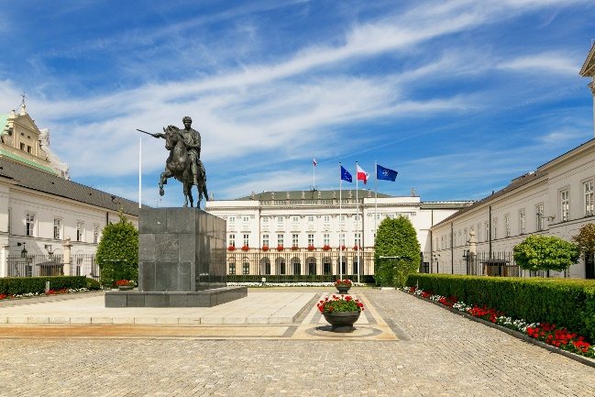
The Presidential Palace is an iconic building located at Krakowskie Przedmieście 46/48, Warsaw, Poland. It is the official residence of the Polish head of state and president. The palace has a rich history and has witnessed many important historical events in Polish, European, and world history. It was originally constructed in 1643 as an aristocratic mansion and has been rebuilt and remodeled several times over the years by notable architects. The current neoclassical palace was completed in 1818. It is one of the largest palaces in Warsaw and is known for its stunning architecture. The Presidential Palace is open to visitors and offers guided tours for groups of up to 35 people. It's a great place to learn about Polish history and experience the grandeur of this magnificent building.
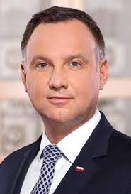
Andrzej Duda is the President of Poland.

Here are 10 questions based on the text about the Presidential Palace in Warsaw:
- What is the official residence of the Polish head of state and president?
- Where is the Presidential Palace located?
- When was the current neoclassical palace completed?
- How many people can join a guided tour at the Presidential Palace?
- What is the address of the Presidential Palace?
- What is the architectural style of the Presidential Palace?
- What was the original purpose of the palace when it was constructed in 1643?
- How many times has the palace been rebuilt and remodeled over the years?
- What is one of the notable features of the Presidential Palace?
- Is it possible to visit the Presidential Palace?
I hope you find these questions interesting! Let me know if you need any further assistance.

Simplified text:
The Presidential Palace in Warsaw is the official residence of the Polish president. It is a neoclassical palace with a rich history, having witnessed many important events in Polish, European, and world history. The palace is open to visitors and offers guided tours.
In simpler terms, the Presidential Palace in Warsaw is the home of the Polish president. It is a beautiful old building with a lot of history. You can visit the palace and take a tour to learn more about it.

(5) Pałac Prezydencki. https://www.prezydent.pl/.

https://youtube.com/shorts/Z4B0NhgbXDA?si=ePo81-p2a9bRo_Cj
https://youtu.be/2MKv4_ZgjHI?si=rLAUg7zqtZJLK2gt

Write a short text for kids, describing the Presidential Palace in Bratislava, Slovakia (about 150 words)
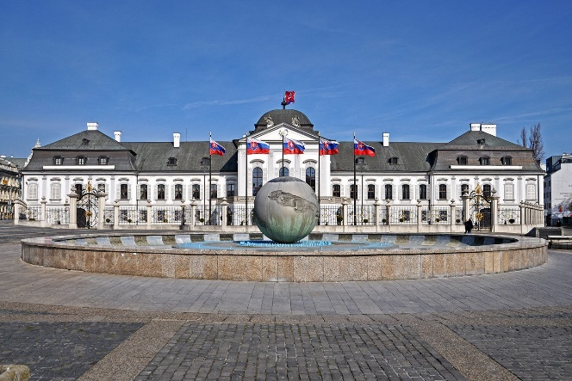
The Presidential Palace in Bratislava, Slovakia is a magnificent building that serves as the official residence of the President of Slovakia. It is located on Hodžovo námestie, near the Summer Archbishop's Palace. The palace is a Rococo-late Baroque summer palace with a French garden. It was built by Count Anton Grassalkovich, an aristocrat of Croatian origin and one of the most important Hungarian politicians. The palace has undergone several reconstructions to restore it to its original form from the 1860s. The entrance hall features a staircase adorned with unique sculptures, leading to the Garden Hall. The Great Hall on the first floor has a preserved partially original gilded stucco decoration. The palace has served as a concert hall in the past and is now used for official welcoming ceremonies and signing important treaties. The second floor houses resting areas for the head of state and most of the office spaces. The chapel of St. Barbara, with original rococo and classicist frescoes, is another valuable space within the palace. The garden behind the Presidential Palace is open to the public and is a popular place for walks among both Bratislava residents and tourists.
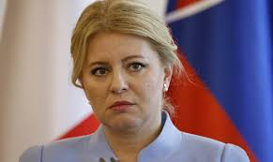
Zuzana Caputova is the President of the Slovak Republic.

Here's a quiz based on the description of the Presidential Palace in Bratislava, Slovakia:
1. Who is the official resident of the Presidential Palace?
2. What is the architectural style of the palace?
3. Who was the palace built by?
4. What is the name of the street where the palace is located?
5. What is the purpose of the Great Hall on the first floor?
6. What type of garden does the palace have?
7. What is the function of the palace today?
8. Which floor houses most of the office spaces?
9. What is the name of the chapel within the palace?
10. Is the garden behind the Presidential Palace open to the public?

I hope you find this quiz enjoyable and informative! Let me know if you have any other questions.

Simplified text:
The Presidential Palace in Bratislava, Slovakia is the official residence of the President of Slovakia. It is a beautiful building with a rich history. The palace has been rebuilt and restored several times, but it still retains its original Rococo-late Baroque style. The palace is used for official events, such as welcoming ceremonies and treaty signings. The garden behind the palace is open to the public and is a popular place for walks.

Bratislava, Slovakia: Presidential palace 🏛 ⛲️ 🇸🇰 - YouTube
https://youtu.be/cQdqC1AM_M0?si=LaXZh2h_PxNmWMOh

