T.: The United Kingdom of Great Britain and Northern Ireland – basic information. | 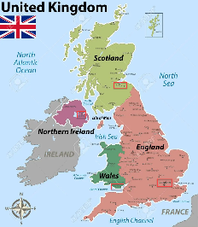
Aim(s):
- Learn some basic facts about UK
- Practice oral communication
- Practice writing a report in a team
- Learn how to present the report to the class
Plan:
- Listen to the short introduction to the topic
- In pairs complete the missing information about a specific country by asking your partner some questions
- In a group write the report about the given country
- Report the collected information to the class

Additional task:
- If you still have some time, complete the quiz about the UK
Homework:
- Finish completing the above-mentioned quiz (https://www.liveworksheets.com/gm1194191pf)
- Explore the UK on google maps (maps.google.com)

